LÜK-TIROL KOPIERVORLAGEN


Gebirgszüge in Tirol
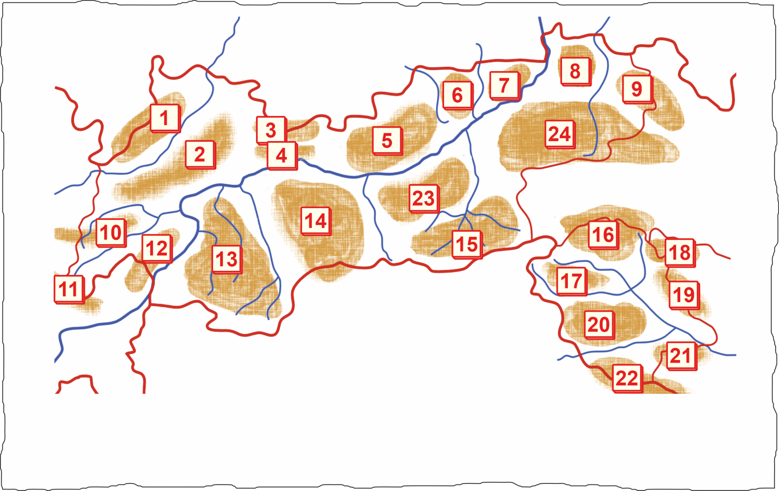

 | 1 |  | 13
 | 2 |  | 14
 | 3 |  | 15
 | 4 |  | 16
 | 5 |  | 17
 | 6 |  | 18
 | 7 |  | 19
 | 8 |  | 20
 | 9 |  | 21
 | 10 |  | 22
 | 11 |  | 23
 | 12 |  | 24

